The more I train the trail-gaited horse, the more I am convinced that his heart and soul is in his mouth, and the gait is in his top line. The old-timers used to say, “the higher the horse’s head, the less brains and the lower the horse’s head, the more brains”. Let’s put a different spin on this and also say that, “The higher the horse’s head, the less gait, and the lower the horse’s head, the more gait. The reason for this is, when we raise the horse’s head too high, his back is more likely to hollow and disconnect the horse’s hindquarters from his mouth. The horse has to be ridden from the rear forward. The flash and bang of the show world tends to create a high-headed horse that unfortunately carries over into the trail-gaited world. Now I don’t want to discount the significance of the show world, for it has its place. A true statement is both worlds need to stretch the top line. What I mean by this is, that if we can round the horse’s back and ride the horse in a round shape, it can, and will, put our gaited horses in his natural shape. So when we do raise the horse’s head, it will cause the horses withers and back to lift, thus lightening the forehand.

If the great masters of the twentieth century, or earlier, would have had the talented gaited horse of today, who knows what level of achievement could have been obtained. Most certainly, we would have a different equine world. As I think of the great masters training scale (1) Rhythm/ Relaxation (2) Looseness (3) Contact (4) Impulsion (5) Straightness and (6) Collection, I realize that you must have these six areas to train your horse successfully. They apply to all gaited horses. These methods were developed to teach all equine owners a system that can maintain the welfare of the horse during his career.

The bottom line is, it does not matter what gaited horse you ride: A Tennessee Walking Horse, Fox trotter, Kentucky Mountain or Rocky Mountain horse, it is the first three areas of the training scale that we get into trouble with our gaited horses. Why? It is because we ride outside his (1) Rhythm /(2) Relaxation /Looseness and (3) contact.

In order for us to be successful on the trails, we must identify two common problems with our gaited horses. The first is the horse’s head is too high. The second, the horse is rode too fast. Both areas can be solved using the training scale. I do believe our trail horses have to exhibit his foundation gait. You need some understanding on what his gait looks like and more importantly, what it feels like. Because it is so important that you know how to identify the gaits of your horse, I will have an article later on gait identification, achieving the gait and understanding the gait. But before your horse can gait properly and consistently, the horse has to learn to relax. Don’t be fooled, a great trail horse can do both areas, the “trail or the rail”, but the first step on developing your horse’s gait is to work on suppling. To have a great horse, we have to show him the ground first (lower his head). I would like to share with you some suppling exercises that will get you on the right track to develop your gaits.

The tack required is a snaffle bit, a saddle and riding crop. You will be starting on the ground, so wear boots and use other safety equipment. Always remembers the horse does out-weigh you and can hurt you. Consider his point-of-view: He is a prey animal and has built-in reflexes to protect himself. Remember, your safety always comes first.

Your horse needs to be sacked out (desensitized) with the riding crop all over his body, and in a relaxed total acceptance of the riding crop.

You will begin this exercise by standing on the ground close to the shoulder of your horse. Use your riding crop and start rubbing the crop all over the horse’s body. The goal is to de-sensitize the horse, so you don’t get an over-reaction when you tap the horse to go forward.
Now stand on the left side of your horse’s head. Use your left hand on the inside rein to gently lift the bit up and down in the horses mouth. Vibrate with your fingers or use a shaking motion. Look for a response that the horse is moving his tongue up and down under the bit and starting to chew. This response indicates the horse is relaxing the poll behind the ears.

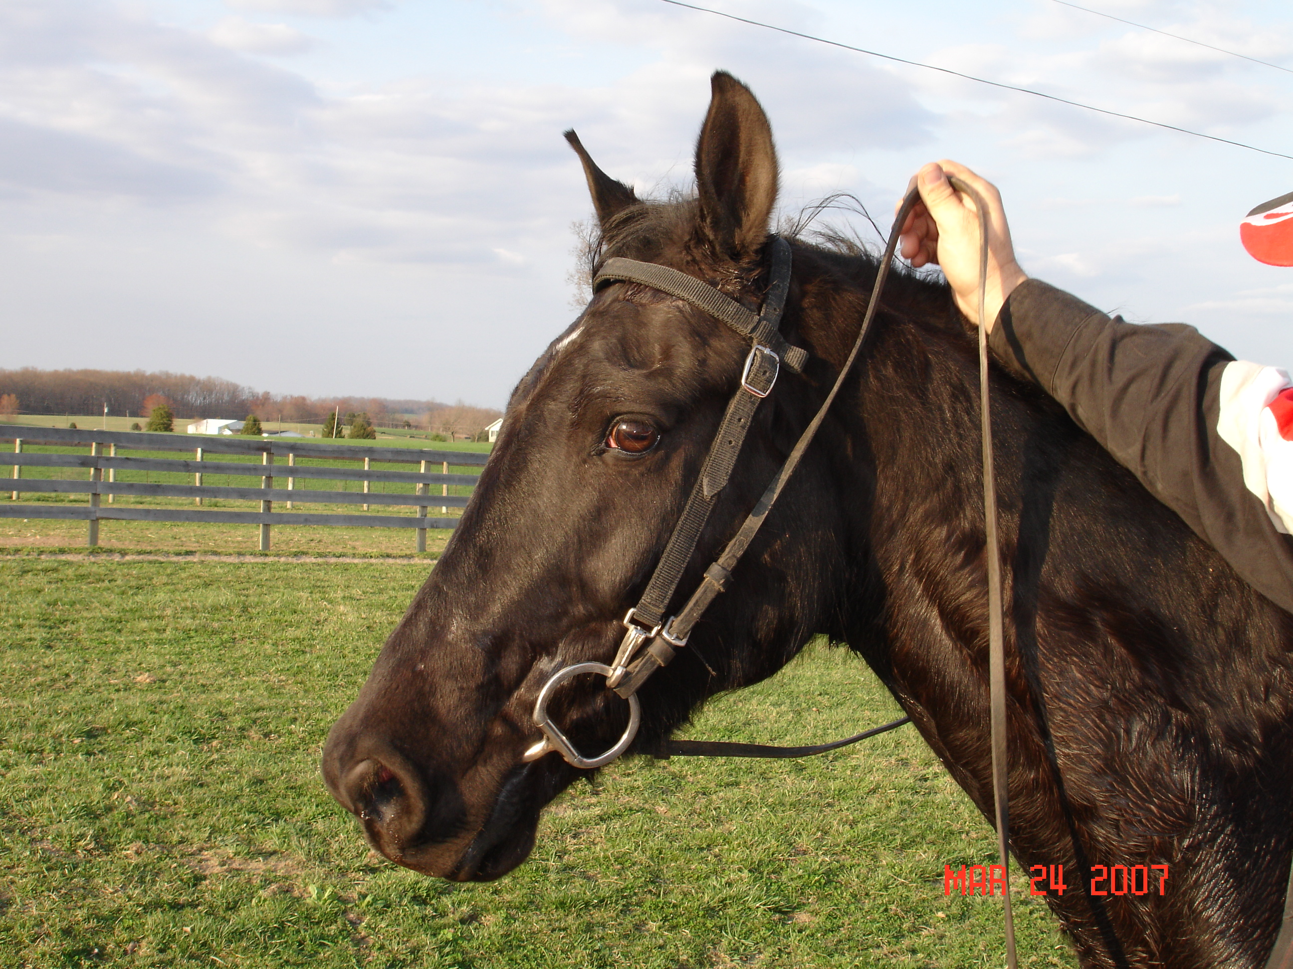

Now, move the horse’s head two to four inches to the left toward you. Use your riding crop in your right hand to gently touch the horse’s hindquarters. When the horse starts to move, pay attention to the elevation of the horse’s head. When he starts to drop his head, release and follow his head down with the rein. This training is progressive in nature and will require some time to teach.

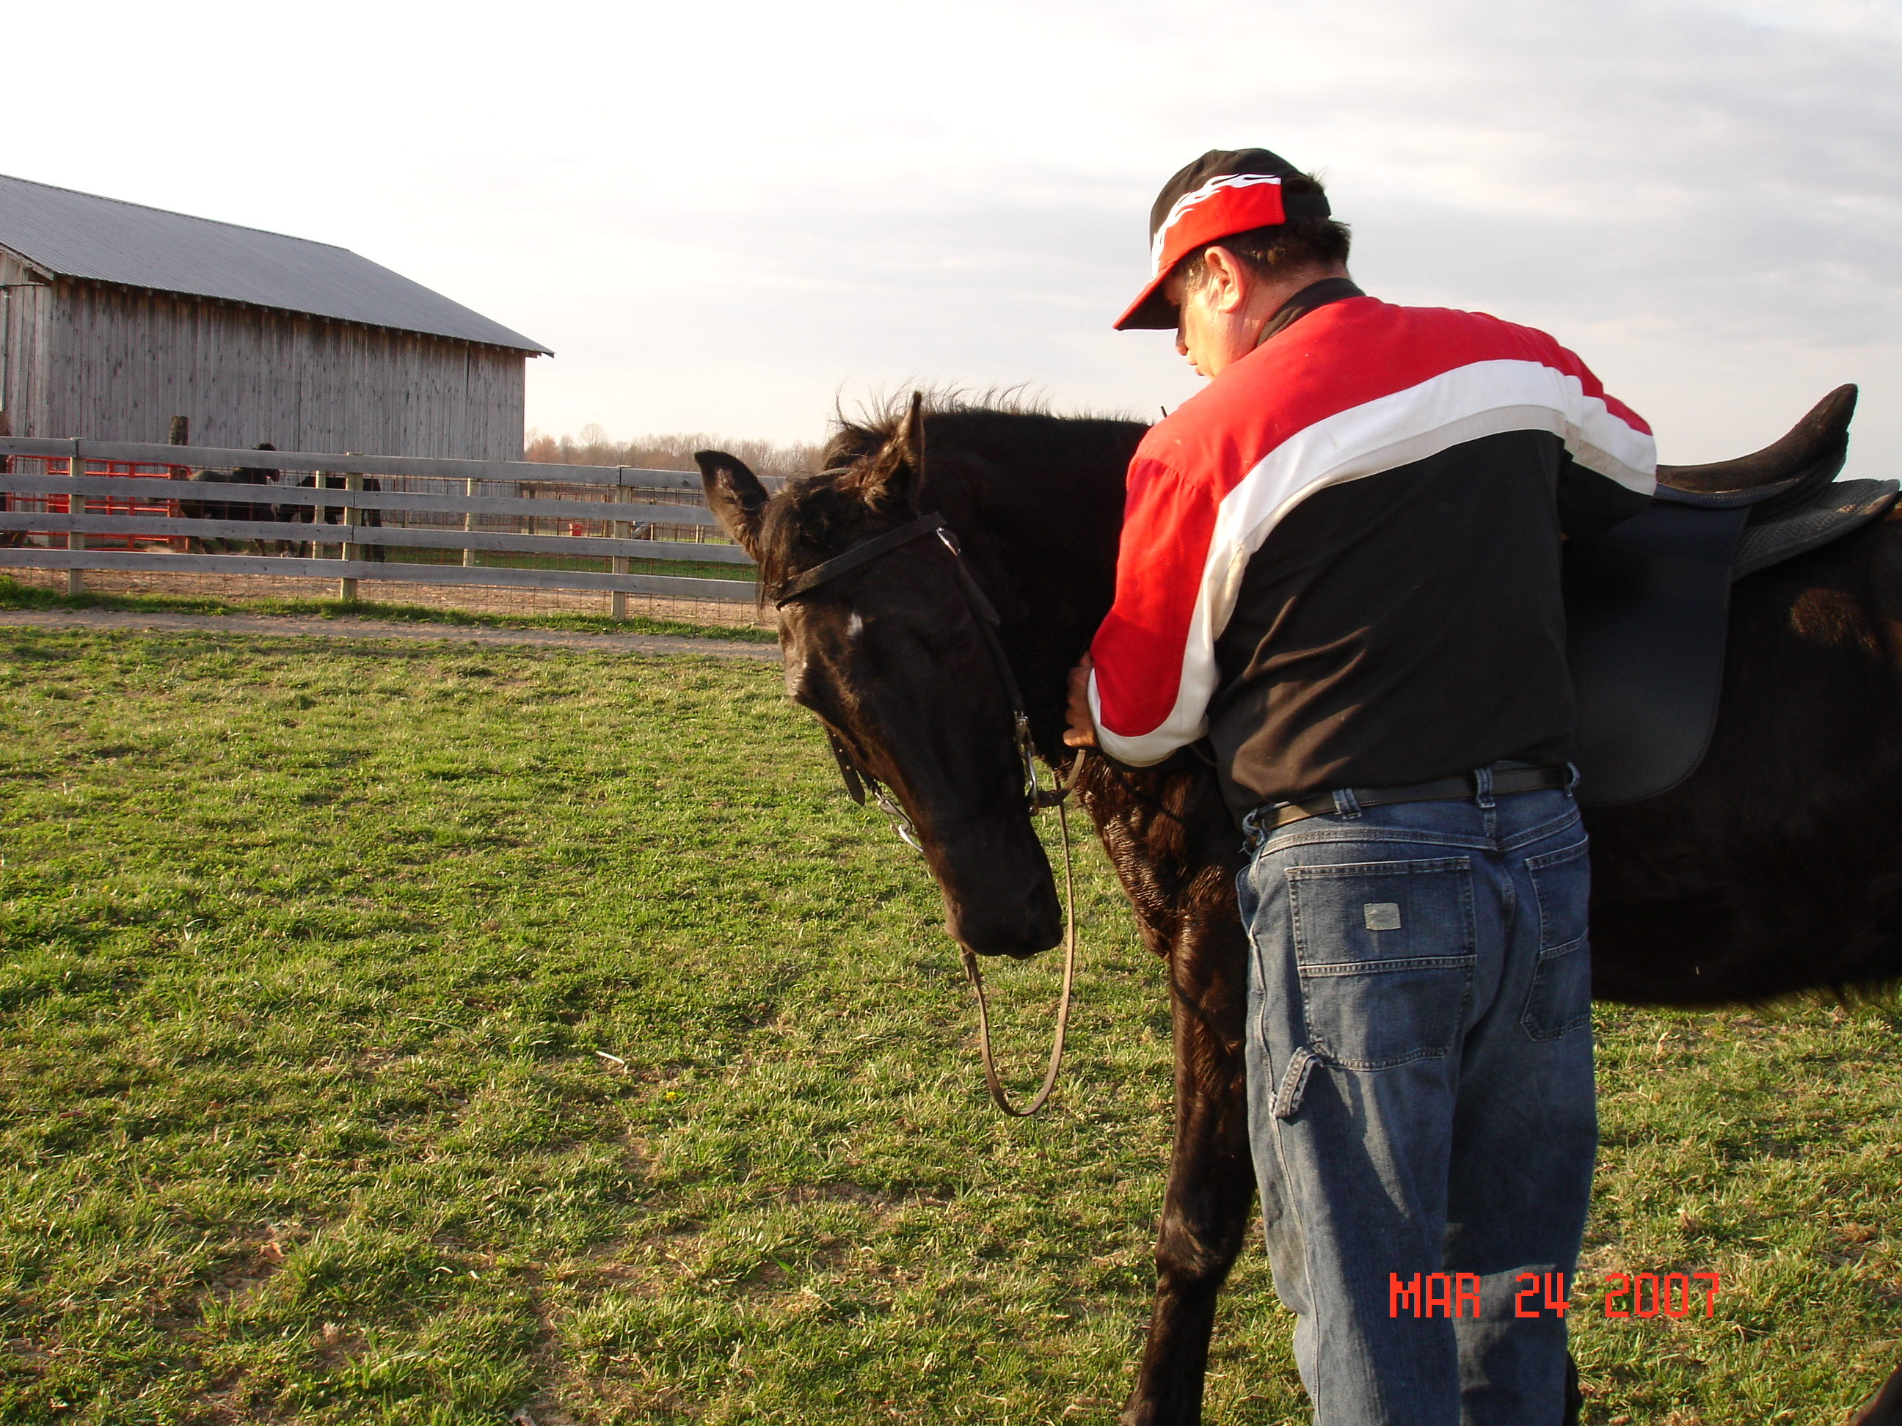

You should be aware that some horses will be reluctant to drop their head.
This is because they have been ridden too long with a high headset creating stiff tension with braces in the poll, neck, and top line. With this kind of horse, there is definitely built in tension. You can at the halt put downward pressure on both reins and ask for lowering or stretching of the head down. This exercise should be done on the ground.
How long will it take to teach this exercise? It can take from one hour to a month, depending on the tension in your horse. The key to understanding the benefit of this exercise is that it develops a long-term relaxation program for a better trail horse.

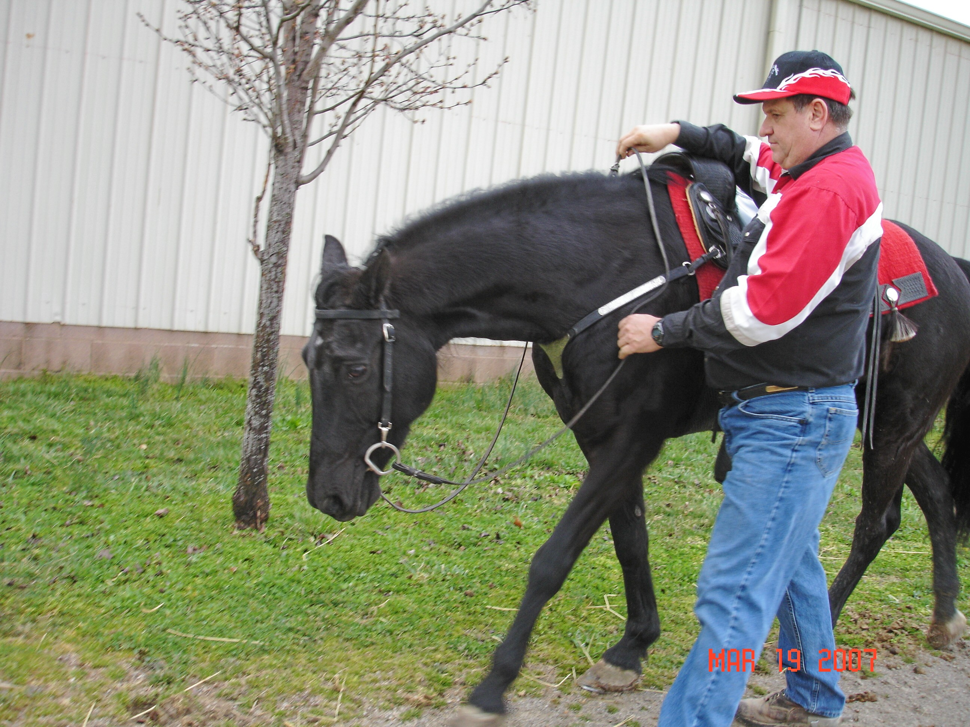

I am not saying you have to go around rolling peanuts on the ground. Your goal is to find the natural position your horse’s head carriage. Remember “the higher the horse’s head, the less brains and the lower the horse’s head, the more brains.”

When I think of the ideal head position for the horse to carry his head on the trail. I think of the 1968 Ford Mustang vehicle that has the horse emblem on the grill . If you can recall this grill ornament, the horse’s head is just out from the neck about even with the withers. .
Getting your horse’s head in a relaxing position provides for the long-term health, and develops the successful gaits of your trail horse.
Just have fun and play with this concept with your trail horse.
“Happy Trails”, Gary Lane
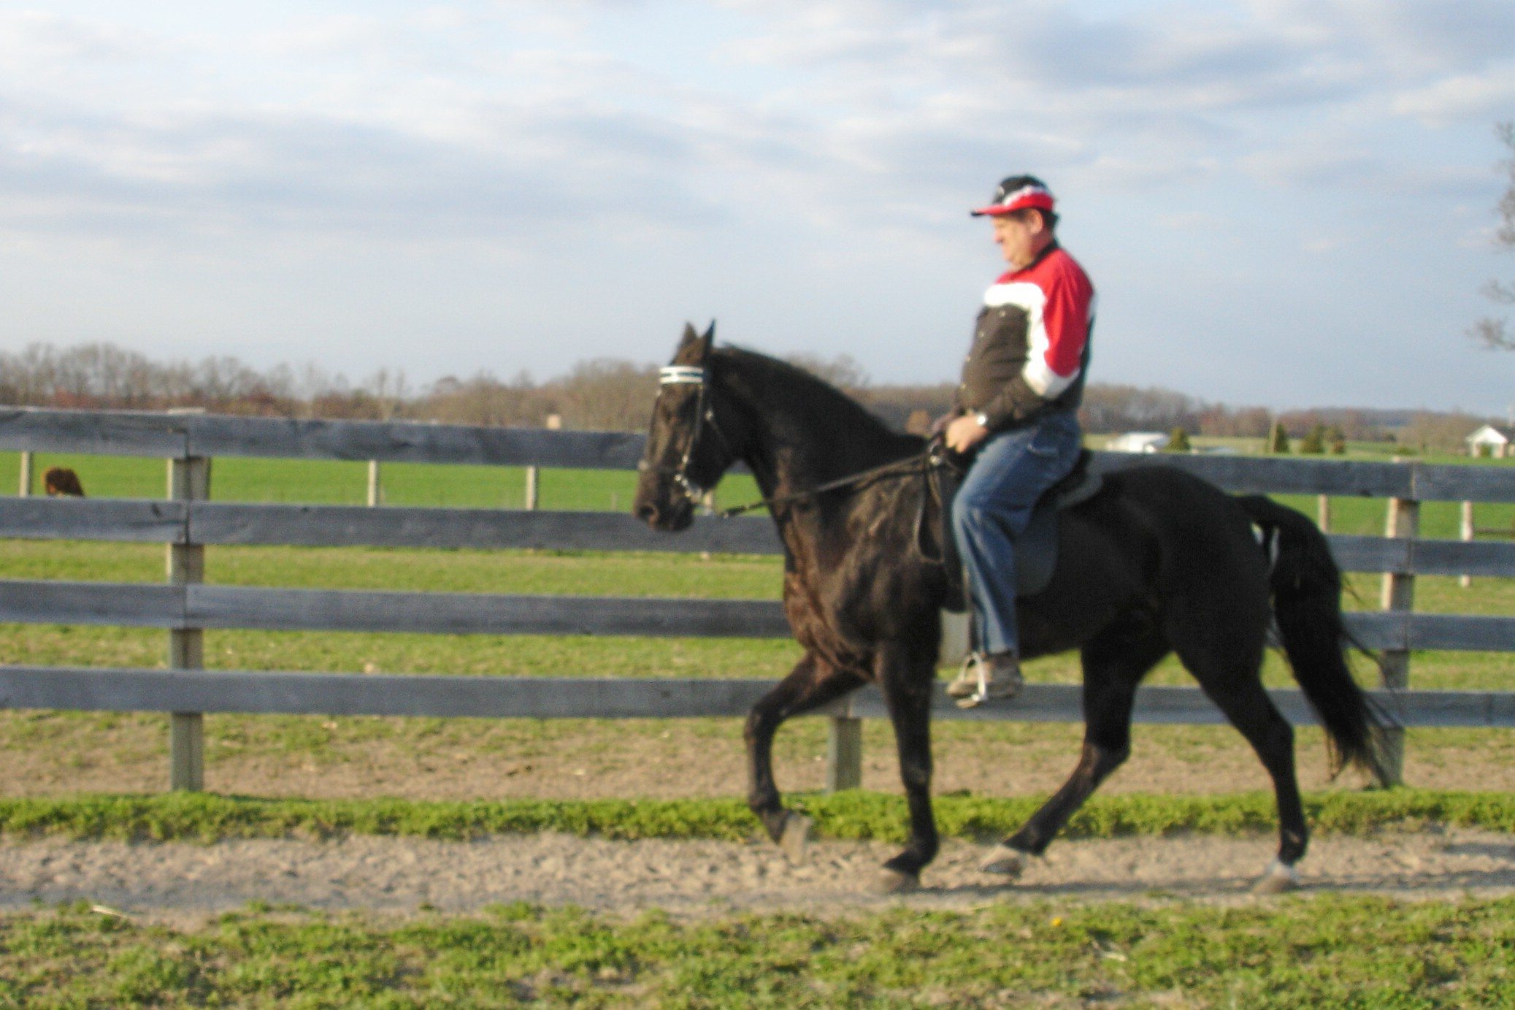

Title: Relaxation exercises to improve all gaited horses.

